**Project name: Capstone Project**

GitHub Link: <https://github.com/Sravanasaikrishna1996/CapstoneProject>

**Make an Website for Food Web application**

This document contains sections for:

* Sprint planning and Task completion
* Core concepts used in the project
* Flow of the Application.
* Demonstrating the product capabilities, appearance, and user interactions.
* Unique Selling Points of the Application
* Conclusions

The code for this project is hosted at

The project is developed by Nallamolu Sravana Sai Krishna

## Sprints planning and Task completion

The project is planned to be completed in 1 sprint. Tasks assumed to be completed in the sprint are:

* Creating the flow of the application
* Initializing git repository to track changes as development progresses.
* Writing the Java program to fulfil the requirements of the project.
* Testing the Java program with different kinds of User input
* Pushing code to GitHub.
* Creating this specification document highlighting application capabilities, appearance, and user interactions.

|  |
| --- |
|  |

When you login fails this will show you a Login Failed message.

|  |
| --- |
|  |

This is the login page where username and password will appear

|  |
| --- |
|  |

New user can register his details. When New user registration success then Success message will appear.

|  |
| --- |
|  |

When same user details already stored in Database, this new registration will be failed.

|  |  |
| --- | --- |
|  |  |

**In Shop page user will see list of All products if the category is not selected from the sidebar, User can also select individual categories and purchase Food items from there.**

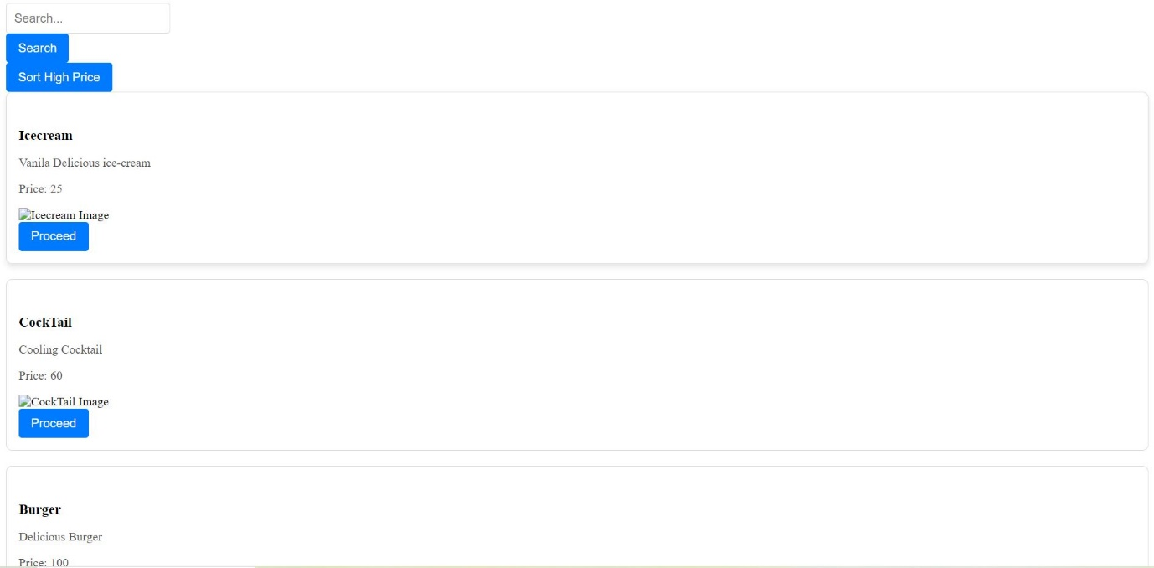

|  |
| --- |
| User can search the products |

User can filter the Products from High price to Low price according to user choice.

|  |
| --- |
|  |

Once user click the Proceed button, It will navigate the Payment page

|  |
| --- |
|  |

Once user Enter those details, Payment success.

|  |
| --- |
|  |

Database:

Login database:

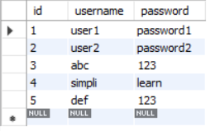

Products Database:

